Getting started with MyAnalytics
Would you like to have more time in your life? Time enough to get work done and have a home life? When we don’t have enough hours in the day, we often make trade-offs. We move a meeting here or there, delay reading emails, scale back on what we hoped to accomplish, or work longer hours.
You can make more deliberate decisions about your trade-offs when you use Microsoft MyAnalytics. And when you get more control over how you spend your time, you can use your time more strategically.
This guide introduces key MyAnalytics concepts, and shows how you can use the dashboard to increase your effectiveness and find more time.

Key concepts—it’s not just data
When you first look at your email and meeting data in MyAnalytics, you’ll probably find it interesting, maybe surprising. But the data is only half of the experience. What you do with the data is what matters most.

Make data-driven time and project management decisions
Every week your dashboard is refreshed with data collected from your previous week’s email and meeting activities. Simplified in high-level charts and graphs, the data can help you find ways to gain time and keep your projects on schedule.
For example, the data can help you to see how to:
- Streamline the amount of time you’re in meetings, so that you can get more time alone—to focus on business and projects.
- Improve your communications style and response time, so you can get projects done more quickly and efficiently.

Cultivate valuable relationships
Not everyone has to juggle meeting, project, and email time. But everyone can benefit from having more time with the people who are most important—at work and at home.
When your business relationships are essential to success, MyAnalytics can help you to stay connected to your most valuable colleagues.

Use weekly goals to help you change your work activities
The MyAnalytics dashboard becomes even more valuable when you create goals for the way you want to spend your work hours. Your attention to these goals can help you organize your time to your advantage. For example:
- If you’re working on a deadline and know you’ll need a lot of uninterrupted time, set your meeting and email goals to a low number, and your focus goals to a high number.
- If you’re returning to work after a vacation and have a lot of emails to read, set your email goals to a high number so that you catch up on emails you missed.
The following week, check to see whether you accomplished your goals—you can keep the same goals, or set new ones.

It’s your data
MyAnalytics uses information from your Office 365 mailbox and calendar, like how many emails you send and receive, and meeting duration. It doesn’t collect content from the body of your emails or your calendar meeting descriptions. What you’ve said to others in your emails and meeting invitations stays private.

Privacy is vital
MyAnalytics uses several precautions to help protect the privacy of everyone who uses MyAnalytics. For example, you’ll only see data about email that you send to five people or more. This protects your recipients’ privacy. You can tell in aggregate what your recipients did, but their individual actions are private.

Working with MyAnalytics
There are two ways to access your MyAnalytics dashboard. You can open it using the Office 365 website and you can open it from your Microsoft MyAnalytics Outlook add-in. The add-in is automatically enabled.

To open MyAnalytics from the website
- Go to https://portal.office.com.
- Select the app launcher , and then select Delve.
In the left pane, select MyAnalytics. Your personal dashboard will open.

To open MyAnalytics from your Inbox
- Open Outlook, open an email that you want get statistics about, and then select MyAnalytics 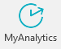 from the ribbon.
- The MyAnalytics add-in pane will open. At the top, you’ll see information about your email.
At the bottom of the pane, select More insights. Your personal MyAnalytics dashboard will open.
NOTE: Depending on when you licensed MyAnalytics and the first time you open it, you might not yet see any information. It can take up to nine days for the setup of your personal dashboard to complete. Until then, you’ll see a message telling you to check back in a few days.

Explore your MyAnalytics dashboard
Get a quick understanding of how you spent your time last week by scrolling through your dashboard. You’ll find data about:
- The time you have to focus on your work without meetings.
- The emails you send and receive.
- Your meetings.
- Your network of people.
- Your collaboration time.

Your weekly summary
At the top of your dashboard is the Your time module—it’s a snapshot of how you spent your time each week. This is also where you see and can adjust your goals. Notice that goals for Meeting, Email, and After hours times show the less than sign (<), and Focus hours shows the more than sign (>). This helps you to pay attention to gaining more Focus hours every week.
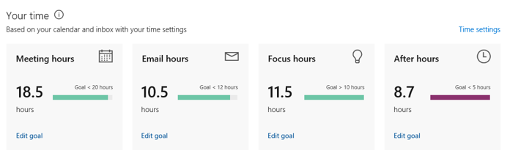
Figure 1. Example of the Your time module of the MyAnalytics dashboard
NOTE: If you don’t work a typical schedule, be sure to set your working hours by selecting Time settings. These hours determine how your Focus hours and your After hours are calculated.

To change your goals
- Select Edit goal, and then enter the number of hours you want.
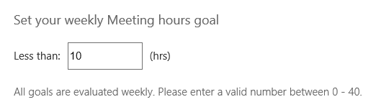
Figure 2. Example of the Set your weekly Meeting hours goal box

Who you spend your time with—your network
The Stay in touch module shows your Important contacts, your Top collaborators, and your time with your manager. You’ll see statistics about your collaboration time, including how quickly you respond to their emails and the percent of their emails that you read. You’ll also see who you might be losing touch with.
This data is a good way to remind yourself of upcoming activities that require your attention. For example, if you notice that you’re behind in email from someone who you’re going to meet with soon, putting them on your Important list helps remind you to read their emails ahead of time.

Important people
Your Important people are your contacts with whom you want to maintain quality relationships. You can see your top four Important people, or select View details to see the full view of your contacts. You can also see you how much time you dedicate to these people.

Top collaborators
Your Top collaborators are the people you worked with the most. To see a list of all your contacts, select View details.
You can move someone from your Top collaborators list to your Important list. To move them, select the Favorites icon by their name. Then when you open your Important list, that person’s information will have been added.

You and your manager
Maintaining a good working relationship with your manager is always important. You can check the health of that relationship by evaluating statistics about how you collaborate with him or her. For example, in the You and your manager module, you’ll see how quickly you and your manager respond to each other’s emails and how many hours you collaborated.
This information can help you to better collaborate and communicate with your manager. For example, you may decide you need more regular one-to-one meetings to make sure you’re aligned on priorities.
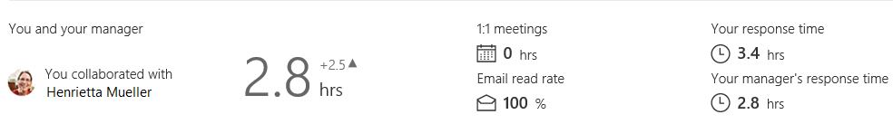
Figure 3. Example of the You and your manager module of the MyAnalytics dashboard.

Losing touch
The people listed in the Losing touch module are colleagues that you haven't collaborated with in meetings or emails for a while. It shows when you last communicated with each other and provides a link if you want to set up a meeting right from MyAnalytics.

My Important groups
You can also get a sense of how you’re collaborating with your teams from the My Important groups module. It shows how much time you’re spending with your most important groups. These could be project teams, hierarchical groups, or even external groups, such as customers or partners.
You can gauge the health of these relationships, based on how much time you’ve spent collaborating compared with goals you’ve set.

Your time in meetings
One way to work more efficiently begins by evaluating your meeting activities. The Meetings module gives you opportunities to improve meeting quality and understand which meetings are the most effective, based on a set of typical meeting characteristics. This data provides objective feedback into everyday effectiveness that you can use to tune your efforts for higher impact.

Meeting module
Do you know how many hours you’re spending in meetings, which meetings are taking up the most time, and the quality of those meetings? The data provided in the Meetings module—Meeting hours and Meeting habits—gives you good insights into these. These insights can help you to make decisions that can improve how you work.
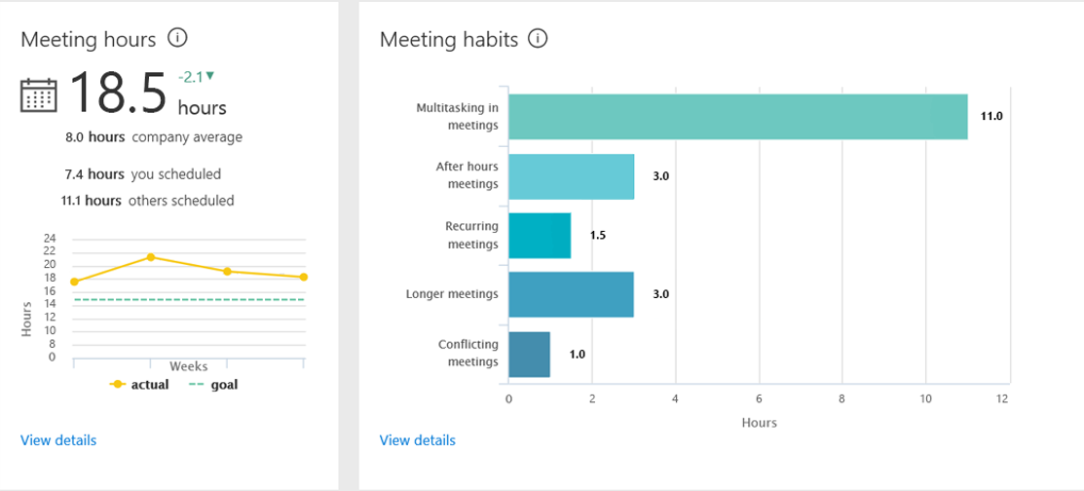
Figure 4. Example of the Meetings module of the MyAnalytics dashboard

Meeting hours
On the left side of the module, the Meeting hours section shows how much time you spent in meetings, whether that’s more than or less than the week before, and how it compares to your company’s average meeting time. It also shows the breakdown between meetings you scheduled yourself and meetings that you were invited to by others.

Meeting habits
If you’re looking for ways to gain more time, the classification of meetings in the Meeting habits area shows which type of meeting to target for further analysis.
To see a list of all of your meetings, select View details. Use this information to identify whether you have meetings that aren’t as valuable as others. If you spend your time routinely multitasking in a meeting, does the meeting have enough value for you to attend regularly?

The time you spend doing emails
When faced with an Inbox of unread correspondence, emails that you’ve read and want to refer to later, meeting invitations and meeting recaps, email newsletters that you’ve subscribed to, and so forth, it can be hard to feel like you have enough time to get through it all.
The Email module helps you understand your Inbox activities so that you can take some actions to reduce the number of hours you spend doing email.
NOTE: You can also use the MyAnalytics Outlook add-in to find your email read rate and activities, like forwards and replies.

Email module
If you set goals to limit your email activity during non-business hours, but the data shows you’re still working a lot during your off hours, the information in Email habits can help you find changes that you can make. For example, you could save drafts or delay delivery of email until your recipients’ normal business hours. And you could limit late night/early morning email to urgent email only.
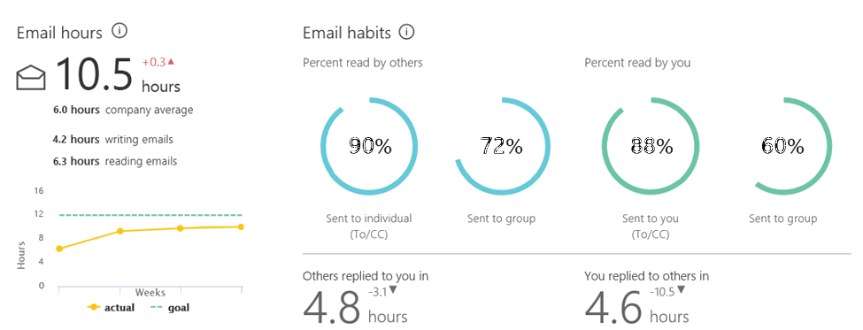
Figure 5. Example of the Email module of the MyAnalytics dashboard

Email hours
On the left side of the module, the Email hours section shows an estimate of how much time you spent writing and reading emails. You can see how these statistics compare to your company’s average and to your personal goals.
To see the time of day (or night) that you send emails, select View details—the Email activity screen also shows how many emails you sent or read during and outside of business hours.

Email habits
On the right side of the module, the Email habits section shows you more detailed information. You can see whether your emails are read more often when they are sent to an individual or to a group, and whether you read more emails that are sent to you versus sent to a group.
This section also shows how many hours it takes on average for others to reply to you and for you to reply to others.

Your focus time
Whether you’re doing email during your focus hours or making notes on your whiteboard, when you have the time to think without being distracted by meetings, you can accomplish a lot. Because most people need at least two hours between meetings to concentrate on their work, focus time is when you have at least two consecutive hours by yourself.
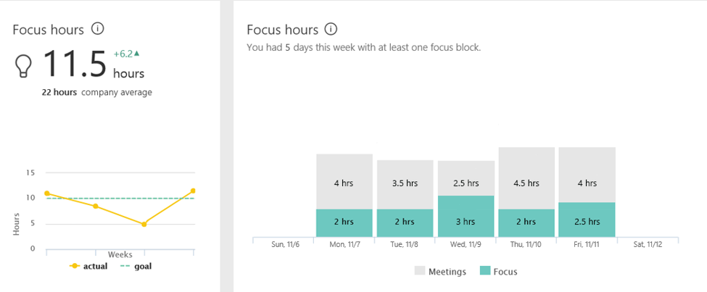
Figure 6. Example of the Focus hours module of the MyAnalytics dashboard

Focus hours
The data in this module helps you to understand whether you need to gain more focus time going forward. For example, if the graph on the left side shows a dip in focus hours compared to your goal, was the dip warranted for that week? Or is there something that you could have done differently to accomplish more?
You’ll also see which days of the week you had more time to focus.
Use this information to evaluate whether you need to adjust meetings in the future so that you can have more focus time. For example, if you usually have two hours of focus time a day, but next week you know you’ll need several days with more focus hours, you can look ahead at your meetings to find ones that can be moved or that you can miss. And, when you set your goal for the week for more hours, you’ll be able to see whether you accomplished it.

The time you spend doing work after hours
The After hours module is highly personal in nature, depending on your work style, personal demands on your time, and other factors. Also, expectations about working after hours may vary by team or role. Many managers want to limit or stop after-hours work so that their teams have time to recharge.
The data shows whether your after-hours time was spent in meetings or doing emails, and on which days of the week, including the weekends.
To better understand your work-life balance, review that data. Do you routinely work after hours to get things done? When you look at your scheduled meetings and volume of email, are there activities that you can remove or reduce so that you spend fewer hours working after hours?

MyAnalytics add-in for Outlook
The MyAnalytics add-in for Outlook provides insights about email and surfaces them right in your Inbox, so you can take action quickly. If you have a MyAnalytics license, this add-in is included in your Outlook.
For more information about this add-in, see Microsoft MyAnalytics add-in for Outlook.

Improve your communications with data about emails you send
When it’s important to know how an email that you sent was received, the MyAnalytics Outlook add-in shows you data that you can use to find the answer.
For example, if the data shows that your weekly status reports have a 50 percent read rate, consider making changes to your report, and then re-checking the read rate results. You may need to iterate a few times to get the read rate you want.
Here are a few ideas for changes you could make:
- Use IM or the phone for short conversations.
- Bring the most important information to the top of your emails so that people see it in their preview and will want to read more.
- If you see that it usually takes your recipients two or more days to read your report, try sending it on a different day or time of day.
- If not everyone needs to know everything, split your report into two or more, and target your audiences with the content most relevant to them.

Enhance work relationships with data about emails you receive
Work relationships and networking are important to professional success. Seeing data about how you respond to emails you receive can help you to pinpoint relationships that you may want to nurture more. You’ll see the average response times between you and a sender, the number of emails you exchanged, and read rate.

Putting it all together
Now that you have access to rich information about how you spend your time at work, the next step is to assess what opportunities you have, take action, and monitor progress. Time management has never been more important.
For tips about how to gain more time in your schedule or gain work/life balance, see Microsoft MyAnalytics tips. It gives ideas to help you spend your time better and to focus on what's most important in your work.

For more information
Microsoft IT Showcase
http://www.microsoft.com/ITShowcase
“Microsoft MyAnalytics add-in for Outlook”:
https://support.office.com/en-us/article/Delve-Analytics-Outlook-add-in-e305ae2d-6f16-4688-b2b0-487c4c2d067b?ui=en-US&rs=en-US&ad=US
“Microsoft MyAnalytics tips”:
https://support.office.com/en-US/article/Microsoft-MyAnalytics-tips-bbe5903a-1ef1-495d-938f-a9afa2ec1e97

©2017 Microsoft Corporation. This document is for informational purposes only. MICROSOFT MAKES NO WARRANTIES, EXPRESS OR IMPLIED, IN THIS SUMMARY. The names of actual companies and products mentioned herein may be the trademarks of their respective owners.

